Label Heart Interior Anatomy Diagram
The heart is a fist-sized, muscular organ that pumps blood through the body. Oxygen-poor blood enters the right atrium of the heart (via veins called the inferior vena cava and the superior vena cava). The blood is then pumped into the right ventricle and then through the pulmonary artery to the lungs, where the blood is enriched with oxygen (and loses carbon dioxide). The oxygen-rich (oxygenated) blood is then carried back to the left atrium of the heart via the pulmonary vein. The blood is then pumped to the left ventricle, then the blood is pumped through the aorta and to the rest of the body. This cycle is then repeated. Every day, the heart pumps about 2,000 gallons (7,600 liters) of blood, beating about 100,000 times.
Label the heart anatomy diagram below using the heart glossary. Note: On the diagram, the right side of the heart appears on the left side of the picture (and vice versa) because you are looking at the heart from the front.
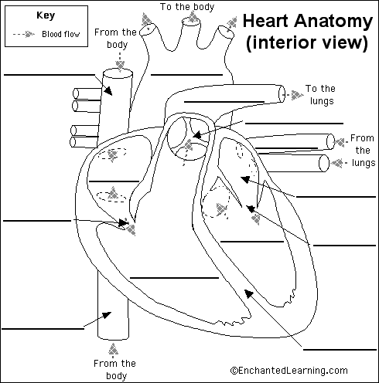

Heart Anatomy Glossary

The heart is a fist-sized, muscular organ that pumps blood through the body. Oxygen-poor blood enters the right atrium of the heart (via veins called the inferior vena cava and the superior vena cava). The blood is then pumped into the right ventricle and then through the pulmonary artery to the lungs, where the blood is enriched with oxygen (and loses carbon dioxide). The oxygen-rich (oxygenated) blood is then carried back to the left atrium of the heart via the pulmonary vein. The blood is then pumped to the left ventricle, then the blood is pumped through the aorta and to the rest of the body. This cycle is then repeated. Every day, the heart pumps about 2,000 gallons (7,600 liters) of blood, beating about 100,000 times.

aorta - the biggest and longest artery (a blood vessel carrying blood away from the heart) in the body. It carries oxygen-rich blood from the left ventricle of the heart to the body.
inferior vena cava - a large vein (a blood vessel carrying blood to the heart) that carries oxygen-poor blood to the right atrium from the lower half of the body.
left atrium - the left upper chamber of the heart. It receives oxygen-rich blood from the lungs via the pulmonary vein.
left ventricle - the left lower chamber of the heart. It pumps the blood through the aortic valve into the aorta.
mitral valve - the valve between the left atrium and the left ventricle. It prevents the back-flow of blood from the ventricle to the atrium.
pulmonary artery - the blood vessel that carries oxygen-poor blood from the right ventricle of the heart to the lungs.
pulmonary valve - the flaps between the right ventricle and the pulmonary artery. When the ventricle contracts, the valve opens, causing blood to rush into the pulmonary artery. When the ventricle relaxes, the valves close, preventing the back-flow of blood from the pulmonary artery to the right atrium.
pulmonary vein - the blood vessel that carries oxygen-rich blood from the lungs to the left atrium of the heart.
right atrium - the right upper chamber of the heart. It receives oxygen-poor blood from the body through the inferior vena cava and the superior vena cava.
right ventricle - the right lower chamber of the heart. It pumps the blood into the pulmonary artery.
septum - the muscular wall that separates the left and right sides of the heart.
superior vena cava - a large vein that carries oxygen-poor blood to the right atrium from the upper parts of the body.
tricuspid valve - the flaps between the right atrium and the right ventricle. It is composed of three leaf-like parts and prevents the back-flow of blood from the ventricle to the atrium.

Answers: Label Heart Interior Anatomy Diagram
The heart is a fist-sized, muscular organ that pumps blood through the body. Oxygen-poor blood enters the right atrium of the heart (via veins called the inferior vena cava and the superior vena cava). The blood is then pumped into the right ventricle and then through the pulmonary artery to the lungs, where the blood is enriched with oxygen (and loses carbon dioxide). The oxygen-rich (oxygenated) blood is then carried back to the left atrium of the heart via the pulmonary vein. The blood is then pumped to the left ventricle, then the blood is pumped through the aorta and to the rest of the body. This cycle is then repeated. Every day, the heart pumps about 2,000 gallons (7,600 liters) of blood, beating about 100,000 times.
Read the definitions, then label the label anatomy diagram below.

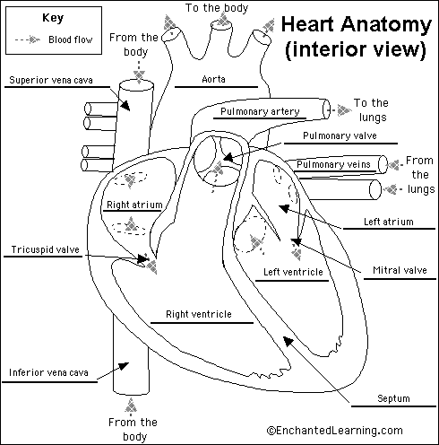

aorta - the biggest and longest artery (a blood vessel carrying blood away from the heart) in the body. It carries oxygen-rich blood from the left ventricle of the heart to the body.  inferior vena cava - a large vein (a blood vessel carrying blood to the heart) that carries oxygen-poor blood to the right atrium from the lower half of the body.  left atrium - the left upper chamber of the heart. It receives oxygen-rich blood from the lungs via the pulmonary vein.  left ventricle - the left lower chamber of the heart. It pumps the blood into the aorta.  mitral valve - the valve between the left atrium and the left ventricle. It prevents the back-flow of blood from the ventricle to the atrium.  pulmonary artery - the blood vessel that carries oxygen-poor blood from the right ventricle of the heart to the lungs. | pulmonary valve - the flaps between the right ventricle and the pulmonary artery. When the ventricle contracts, the valve opens, causing blood to rush into the pulmonary artery. When the ventricle relaxes, the valves close, preventing the back-flow of blood from the pulmonary artery to the right atrium.  pulmonary vein - the blood vessel that carries oxygen-rich blood from the lungs to the left atrium of the heart.  right atrium - the right upper chamber of the heart. It receives oxygen-poor blood from the body through the inferior vena cava and the superior vena cava.  right ventricle - the right lower chamber of the heart. It pumps the blood into the pulmonary artery.  septum - the muscular wall that separates the left and right sides of the heart.  superior vena cava - a large vein that carries oxygen-poor blood to the right atrium from the upper parts of the body.  tricuspid valve - the flaps between the right atrium and the right ventricle. It is composed of three leaf-like parts and prevents the back-flow of blood from the ventricle to the atrium.

