Waves – A Ripple Tank Activity
Standards
1.2.8 A Read and understand essential content of informational texts and documents in all academic areas
3.1.10. C. Apply patterns as repeated processes or recurring elements in science and technology
3.2.10 B Apply process knowledge and organize scientific and technological phenomena in varied ways
Introduction and background
When your parole officer leaves after his/her weekly visit, you extend your arm high into the air and “wave” it back and forth. Why is that action called “Waving”? Just exactly what is a wave? Generally speaking a wave is a motion that oscillate (or moves) back and forth between two extreme positions so we say you’re “waving”. Wave motion or behavior can be observed including (but not limited to) water waves like you might see at the shore or in a pond after you’ve thrown a rock in. Light and sound are often treated as waves.
If you picture a kid on a teeter totter moving up and down you are visualizing motion that is like a wave. At a time of zero the kid is down sitting against the ground. After a second he is halfway up , and a second later he is at the top. A second later he is halfway again, and finally,
a second later he is down on the ground. This motion repeats over and over again. If this motion was plotted versus time it might look like:
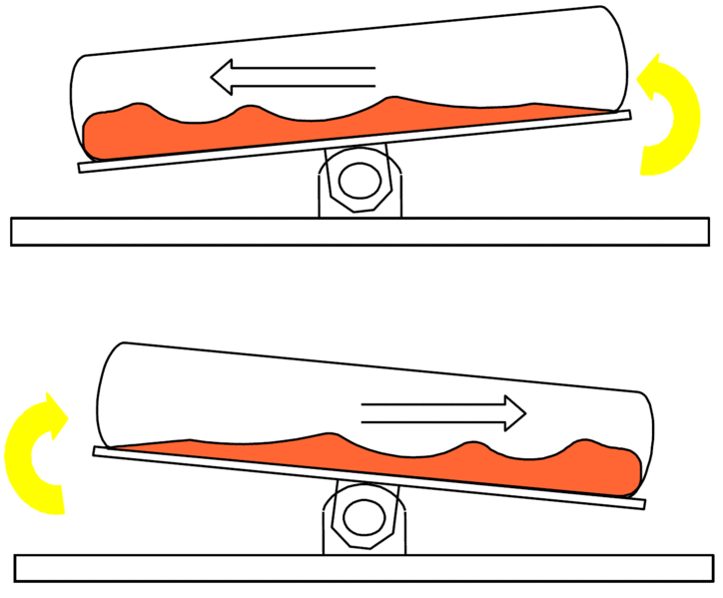
This two-day activity is designed to introduce various aspects of wave behavior. On the first day we will see how waves behave that are produced by line and point sources, measure wavelength and frequency, observe interference created by multiple sources and the Doppler Effect. On the second day five stations will be arranged each demonstrating a different wave phenomenon including wave reflection from both line and point sources, refraction, diffraction, and interference.
Guiding Questions
What effect to do you think the amount of force on water has on a wave?
What do you think makes waves “crash”?
Vocabulary

transverse wave- any wave that oscillates across the two-dimensional plane through which it travels; any wave that causes a crosswise disturbance of the medium through which it travels
longitudinal wave- a wave in which the direction of displacement is the same as the direction of propagation, as a sound wave.
standing wave- a wave in a medium in which each point on the axis of the wave has an associated constant amplitude ranging from zero at the nodes to a maximum at the antinodes.
wavelength- the distance, measured in the direction of propagation of a wave, between two successive points in the wave that are characterized by the same phase of oscillation.
frequency- the number of cycles or completed alternations per unit time of a wave or oscillation.
node- a point, line, or region in a standing wave at which there is relatively little or no vibration.
antinode- the region of maximum amplitude between two adjacent nodes in a standing wave.
reflection- the replacement of each point on one side of a line by the point symmetrically placed on the other side of the line
refraction -the change of direction of a ray of light, sound, heat, or the like, in passing obliquely from one medium into another in which its wave velocity is different.
diffraction- the bending of waves, esp. sound and light waves, around obstacles in their path.
interference- The variation of wave amplitude that occurs when waves of the same or different frequency come together.
superposition- The combination of two or more physical states, such as waves, to form a new physical state in accordance with this principle.
doppler effect- the shift in frequency (Doppler shift) of acoustic or electromagnetic radiation emitted by a source moving relative to an observer as perceived by the observer: the shift is to higher frequencies when the source approaches and to lower frequencies when it recedes
focal length- the distance from a focal point of a lens or mirror to the corresponding principal plane
focal point- either of two points on the axis of a mirror, lens, or other optical system, one point being such that rays diverging from it are deviated parallel to the axis upon refraction or reflection by the system and the other point being such that rays parallel to the axis of the system converge to the point upon refraction or reflection by the system.

Materials
*per group
- 1 ripple tank kit Extra rubber bands
- Medical Gauze Variable voltage power source 0-6 volts
- One metric ruler Adjustable hand strobe or light strobe
- Stop watch Paraffin wax blocks
- .5 In masking tape Protractor
Procedure
- Assemble ripple tank
  - Clean surfaces of the ripple tank
  - Attach legs to ripple tank
  - Spread viewing screen below the tank
  - Level the tank by pouring 5-7 mm of water into the tank, make sure the over flow cork is in the overflow hole. Adjust to levelers on the ends of each leg to get the tank as level as possible.
  - Thread light source rod into the center hole and clamp the light source onto the rod.
  - Place a 5 cm strip of ½ inch masking tape to the bottom of the tank and adjust the height of the light to produce a clear image of the tape on the plastic screen.
  - Cover the beaches edges with one layer of gauze

- Pulses
  - Lightly touch the surface of the water near the middle of the ripple tank. Study the wave you’ve created. Notice that the wave front travels outward with a constant speed from the point where your finger touched the water.

Question: When creating a circular wave does speed of the pulse depend at all on how quickly your finger touched the water?

Measure the distance from the spot on the viewing screen where you touch the water to edge of the screen. Time how long it takes for the pulse to get from the contact point to the edge. Determine the speed of the pulse from the screen (
distance/time).Repeat touching the water faster and slower and determine the speed for each. Does it change appreciably?
Draw a diagram of what you observe each of the times you touch the tank.

b. Place the dowel in the water and move it (roll it) forward a small amount.
Notice the shape of the wave front. This time you should see a straight wave (or plane wave) travel across the tank.
Question: Is the speed of this wave front the same as the circular wave? Question: How could you find out?
Question! Will the speed of the waves change if you push on the dowel rather than pull on the dowel to create a disturbance?
Discovery: Determine this as we did above.

Part II
- Reflections
  - Reflection from a point source: Place a flat obstruction, paraffin wax or wood is fine, near the middle of the tank. Create a wave pulse by dipping your finger into the water.
Observation: What happens as the wave strikes the barrier?
Observation: What does the reflected wave look like?
Question: why do you think the wave looks like this?

  - Reflection from line force: Use a dowel or any long object to create a plane wave. First position the barrier so that the waves run parallel to it.
Observation: What does the reflected wave look like?
Position the barrier so that the waves hit the barrier at a different angle. Place a pencil on the screen so that it is perpendicular to the shadow from the barrier.
Observation: Is the angle created by the incoming wave similar or even identical to the angle reflected off the barrier?

  - Try replacing the straight barrier with a parabolic, curved barrier. Place the curved side toward the wave source. Create a plane pulse.
Observation: What is the shape of the reflected wave?
Observation: Is there a spot in front of the curved mirror where the reflected wave meets?
Procedure: Repeat this, but change the angles at which the waves approach the parabolic reflector.
Question: Did the focal length change or did the position of the focal point change.
Observation: What does the reflected wave look like?
Observation: What does the wave look like now?

Parabolic reflectors are used in a variety of places from reflecting telescopes that receive straight line waves and concentrate them on a point to flashlights that create a point source of light and spreads the light out. Even satellite TV antennas which gather radio waves from a satellite and concentrate it in a receiver.

- Traveling waves:
All periodic waves can be described by this relationship

Velocity = wavelength X frequency

Substituting in v for the velocity of the wave, λ for wavelength of the wave, and υ for the frequency of the wave one gets v= λυ.

This relationship can be investigated by using the ripple tank. To generate periodic waves set up the straight wave generator, connect the motor to a variable DC power source, and add water to a depth of abut 5 to 8 millimeters. Note you may have to adjust the generator with different length rubber bands so that the generator just comes in contact with the water.

Determining Frequency: Practice using the stroboscope so that when viewing through the top portion of the stroboscope you can spin it so that you see a standing wave. Determine how many openings per second are produced when you spin the disc of the stroboscope when the standing wave is produced. It is hard producing a constant spin to produce this frequency. Thus we will use a strobe light. The frequency at which a frozen wave is produced is at 10 slots per second or in the case of the strobe 10 flashes per second or a frequency of 10 Hertz. The frequency used should be the lowest frequency used to freeze the wave, because multiples of this frequency will also produce a frozen wave. This frequency will correspond to the frequency of the wave produced.
Determining wavelength: Once you have visually frozen the wave with the stroboscope or strobe light, have your lab partner position two pencils or rulers on the screen below the ripple tank: The pencils being parallel to the waves and several wavelengths apart. To measure the wavelength you must measure the distances between the two pencils and divide by the number of waves between the pencils. This will give you the shadow wavelength. Then you must account for the difference in scale between the screen and the ripples in the tank. Place a 2 cm piece of masking tape, this should be measured and not estimated, under the ripple tray so that the length of the tape is perpendicular to the wave front. Measure the length of the shadow produced by the tape on the screen. From this ratio: Length of masking tape/ length of masking tape shadow = Actual wavelength / measured shadow wavelength one can determine the wavelength of the waves in the tank.

Length of masking tape = Actual wavelength
Measured shadow length Measured wavelength on the screen

Calculate the speed using the Velocity = wavelength times frequency equation. Now try varying the frequency and determine the speed at each new frequency.
Question how do these values compare?

If time permits you may wish to try this experiment using different water depths.
The best results occur if you try two extremes very shallow water and very deep water.
Question: How do the wavelength, frequency and speed vary with increased and decreased water depth?
5. Refraction: In the last experiment we found that wave speed varies with water depth. Therefore, water of different depths could be used to simulate different materials that cause light to speed up or slow down.
  - Place a piece of glass on spacers so that the surface of the glass is approximately 1.5 cm above the bottom of the tank.
  - Fill the tank so that no more than 2mm of water above the glass late and that this level is somewhat uniform over the entire plate
  - Align the edge of the glass plate so it is parallel to the ripple bar.
Question: What will happen to the waves as they pass over the glass plate will the wavelength get longer or shorter will the speed increase or decrease? What will happen to the frequency?
d. Test: Using a low frequency wave test your hypothesis. You have already done this before. So measure the wavelength, frequency, and speed using those methods.
- Next turn the glass plate so that the incident waves will strike
the edge of the glass at an angle.
Question: Do the waves travel straight over the glass plate or do they bend, refract, when the cross the boundary between the two regions? If yes then measure the angle using a protractor.

- Procedure: Trying to keep the frequency as constant as possible measure the angle of refraction for several other incident angles.
Question: Was this angle always the same?

6. Waves and obstacles
a. Place a small smooth of wood or paraffin block in the ripple
tank about 10 cm in front of the straight wave generator.
Question: Do the waves continue in their straight line path?
Question: How far behind the block does the “shadow” remain in
Existence?
- Change the frequency of the wave generator and observe the region near the edges of the block.
Question: How is the shadow affected by increasing the frequency?
Question: How is the shadow affected by decreasing the frequency?
Question: What frequency range produces the sharpest shadow?
- Replace the block with an open slit by placing two blocks
across the tank and leaving a small gap between them.
Question: When straight waves are incident on the opening, what do the waves exiting the opening look like?
- Keeping the frequency constant, change the width of the
opening
Question: How does this affect the shape of the exiting wave?
e. Repeat this experiment using several different frequencies
Question: What affect does changing the frequencies have on the exiting wave.

7. Interference
- Replace the straight wave generator with the point source
generator. Again one might need different rubber bands for hangers.
Make sure that the two point sources just touch the water. Be careful so that the bar the point sources are on doesn’t touch the water.
Question: How will two circular waves of the same frequency interact?
- Place the point sources approximately 5 cm apart and start
the generator.
Question: How would you describe the resulting wave patterns?
8. Doppler Effect
a. To observe the Doppler Effect touch your finger to the water surface repeatedly as you move your finger from one side of the tank to the other side. Try to be sure the taps are done with equal time intervals.
b. Draw what you observe.

Calculations:
Calculate the frequency of the wave.

Questions:
1. How does the plane wave differ from the circular wave?

2. Are the speed and or height of the wave dependent upon striking force?

3. Draw a wave form and label the following parts: wavelength, peak, trough or valley, amplitude:

4. Write a statement of the Doppler Effect. What happens “in front” of the wave and what happens “behind” the wave?

5. Using the tape measurements and shadow measurements calculate the wavelength.

References
http://upload.wikimedia.org/wikipedia/commons/thumb/7/7c/Wave_Motion.gif/724px-Wave_Motion.gif

