Enviroscape Model
with Topographical Maps
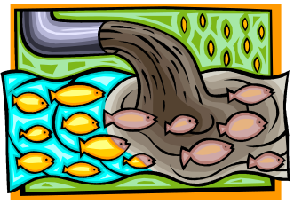

Objectives:

Identify characteristics of characteristics of a watershed.
Identify some problems facing the quality of water in this model watershed.
Identify areas of possible pollution in the Enviroscape Model Watershed.
List two types of point source pollution.
List two types of nonpoint source pollution.
Suggest possible ways to reduce or eliminate the source of the pollution.

Subjects:

Environment and Ecology
Geology

Materials:

Enviroscape Model for Watersheds
Supplies that are needed for use with the Enviroscape Model for Watersheds.
Extra plastic container for waste “well” water.

Background information:

We all live in a watershed -- the area that drains to a common waterway, such as a stream, lake, estuary, wetland, or ultimately the ocean -- and our individual actions can directly affect it. EPA and its partners are working together on a watershed basis to protect the nation's water resources. (http://www.epa.gov/owow/)

At the base or bottom of a watershed will be a body of water. It may be a lotic system, running water, such as a river, creek, or a stream. It could also be a lentic system such as a lake, swamp, or pond.

A watershed is also described in the following ways:
“The area of land where all of the water that is under it or drains off of it goes into the same place. John Wesley Powell, scientist geographer, put it best when he said that a watershed is:
"that area of land, a bounded hydrologic system, within which all living things are inextricably linked by their common water course and where, as humans settled, simple logic demanded that they become part of a community."
Watersheds come in all shapes and sizes. They cross county, state, and national boundaries. No matter where you are, you're in a watershed!
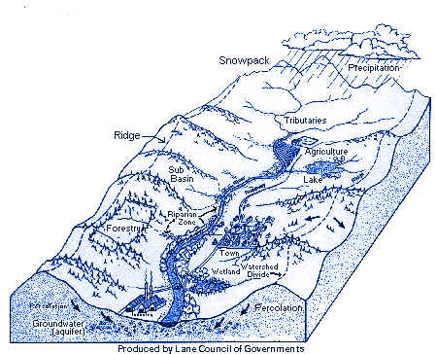

http://www.epa.gov/owow/watershed/whatis.html

The study of watersheds is integral to the study of the environment. Causes of pollution include point source pollution and nonpoint source pollution. Point source pollution is caused by one or more specific sources. One can point to the cause or source of the pollution. It is easier to clean up or at least analyze than the source of point source pollution. Examples of point source pollution include a tanker truck wreck on the hiway or an industrial spill situation. Nonpoint source pollution is produced by one or usually more than one source. It can be natural or human generated. It is very hard or impossible to pinpoint the exact source of the pollution. This in complicates the clean-up and the responsibility for clean-up of the pollution. Many sources may contribute to the source of nonpoint source pollution. Examples of nonpoint source pollution are: lawn or agricultural fertilizers and pesticides or the most abundant form of pollution: sediment pollution.

Procedure:

- Students will be divided into 7 or 8 lab groups.
- Each lab group will list identify two or more sources of point source pollution for their area.
- Each lab group will identify two or more sources of nonpoint source pollution for their area.
- Students will identify the area of pollution on the Enviroscape model using both the items provided and a small piece of cardstock paper.
- Students will explain the type and source of pollution on the assignment paper provided.
- Students will suggest ways to reduce or eliminate the pollution on the Enviroscape Model. They will write the pollution solution on the paper provided.
- Students will also add the solution to the Enviroscape Model with the supplies provided and a small piece of cardstock paper.

Name/s: ________________________

________________________________
Date: __________________
Period: _________________

Assignment

1. What is the area and situation that you have been assigned?
________________________________________________________________________________________________________________________________________________________________________________________________________________________

2. Name two types of point source pollution that could affect your area the problem/s that might result from this pollution. Suggest a solution to prevent or reduce further pollution in the future.

Point Source Pollution
Type of Pollution | Source | Solution

3. Name two types of nonpoint source pollution that could affect your area the problem/s that might result from this pollution. Suggest a solution to prevent or reduce further pollution in the future.

Nonpoint Source Pollution
Type of Pollution | Source | Solution

- Place your point and nonpoint source pollution on the Enviroscape Model. Label the type of pollution and whether it is point source or nonpoint source pollution. Use the cardstock paper provided.

- Show and describe how to prevent or greatly reduce the above types of pollution on the Enviroscape Model. Use the cardstock paper provided.

- Be prepared to tell the class what type of pollution you have created and how you are cleaning it up or how you are going to prevent it in the future.

Teacher Page

Standards:

Watersheds and Wetlands ..……

Cycles

Role of watersheds
- Physical Factors

Characteristics and functions of
Wetlands
E. Impacts of watersheds and wetlands

4.1.4. GRADE 4 | 4.1.7. GRADE 7 | 4.1.10. GRADE 10
Pennsylvania's public schools shall teach, challenge and support every student to realize his or her maximum potential and to acquire the knowledge and skills needed to:
- Identify various types of water environments.  - Identify the lotic system (e.g., creeks, rivers, streams).  - Identify the lentic system (e.g., ponds, lakes, swamps).  - Explain the differences between moving and still water.  - Explain why water moves or does not move.  - Identify types of precipitation.  - Identify living things found in water environments.  - Identify fish, insects and amphibians that are found in fresh water.  - Identify plants found in fresh water.  - Identify a wetland and the plants and animals found there.  - Identify different kinds of wetlands.  - Identify plants and animals found in wetlands.  - Explain wetlands as habitats for plants and animals.  - Recognize the impact of watersheds and wetlands on animals and plants.  - Explain the role of watersheds in everyday life.  - Identify the role of watersheds and wetlands for plants and animals. | - Explain the role of the water cycle within a watershed.  - Explain the water cycle.  - Explain the water cycle as it relates to a watershed.  - Understand the role of the watershed.  - Identify and explain what determines the boundaries of a watershed.  - Explain how water enters a watershed.  - Explain factors that affect water quality and flow through a watershed.  - Explain the effects of water on the life of organisms in a watershed.  - Explain how water is necessary for all life.  - Explain how the physical components of aquatic systems influence the organisms that live there in terms of size, shape and physical adaptations.  - Describe the life cycle of organisms that depend on water.  - Identify organisms that have aquatic stages of life and describe those stages.  - Explain and describe characteristics of a wetland.  - Identify specific characteristics of wetland plants and soils.  - Recognize the common types of plants and animals.  - Describe different types of wetlands.  - Describe the different functions of a wetland.  - Describe the impact of watersheds and wetlands on people.  - Explain the impact of watersheds and wetlands in flood control, wildlife habitats and pollution abatement.  - Explain the influence of flooding on wetlands. | - Describe changes that occur from a stream’s origin to its final outflow.  - Identify Pennsylvania’s major watersheds and their related river systems.  - Describe changes by tracing a specific river’s origin back to its headwaters including its major tributaries.  - Explain the relationship among landforms, vegetation and the amount and speed of water.  - Analyze a stream’s physical characteristics.  - Describe how topography influences streams.  - Explain the influence of mountains on precipitation.  - Explain how vegetation affects storm water runoff.  - Delineate the boundaries of a watershed.  - Describe factors that affect the quality of groundwater.  - Explain how the speed of water and vegetation cover relates to erosion.  - Describe the physical characteristics of a stream and determine the types of organisms found in aquatic environments.  - Describe and explain the physical factors that affect a stream and the organisms living there.  - Identify terrestrial and aquatic organisms that live in a watershed.  - Categorize aquatic organisms found in a watershed continuum from headwater to mouth (e.g., shredder, predator, decomposer).  - Identify the types of organisms that would live in a stream based on the stream’s physical characteristics.  - Explain the habitat needs of specific aquatic organisms.  - Describe the multiple functions of wetlands.  - Describe wetlands in terms of their effects (e.g., habitat, flood, buffer zones, prevention areas, nurseries, food production areas).  - Explain how a wetland influences water quality, wildlife and water retention.  - Analyze wetlands through their indicators (e.g., soils, plants, hydrology).  - Identify and describe natural and human events on watersheds and wetlands.  - Describe how natural events affect a watershed (e.g., drought, floods).  - Identify the effects of humans and human events on watersheds.

Time Required:

The above activity should be able to be completed in one class period but it could easily be two class periods.

Considerations/Students should already know:

How to determine the boundaries of a watershed.
They may be various types of pollution that would cause point source pollution and nonpoint source pollution.

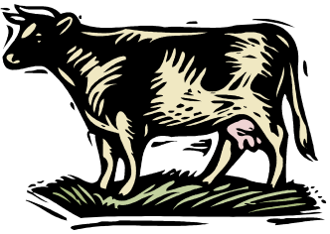

Dairy Farmer Scenario:

You work on the family farm. It is the most wealthy farm in the area. It has 500 cows and 150 acres of farm land. Half of the land is in corn and feeder crops (150 acres) and 30 acres are in hay. The remaining last is used for various building associated with housing the cows, the dairy operation and the house. More land is leased from neighbors that is also used for growing various crops. The Raging River is downhill about ¼ mile from the farm.



Factory:

You and your family own a textile plant. You make and dye material for clothing. Your factory is near a small pristine stream, the Shining Stream. The industry relies on the water. Trout fishermen like to fish in the water above and below the factory. The factory employs about 178 people in this small community.

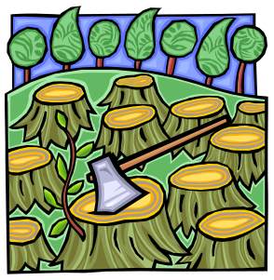

Logger:

Your family owns a lumber yard that makes hardwood paneling and flooring. Raw trees are sawed into boards and then into smaller boards used for paneling and hardwood flooring. Many chemicals are used to treat and stain the wood. These chemicals include glue used to make the parquet flooring. The lumber yard is beside a large river. The lumber yard is also in charge of cutting and transporting large numbers of trees to the lumber mill on a daily basis. The lumber mill is on the banks of the Raging River.

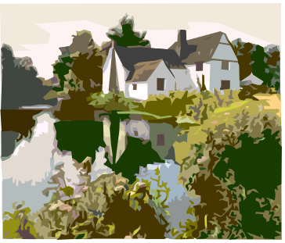

Hobby Farmer:

You are an attorney. You live with your family (wife and three children) on a 30 acre hobby farm on the banks of the Shining Stream. You have an 18 acre lawn and 6 acres that are fences. You have 5 horses. You purchase all of the feed for the horses. You also have three Labrador Retrievers. Your driveway is ½ mile long to reach the house at the back part of the property. Your lawn is emzculatae with neatly mowed, weed-free grass. You have an uninterrupted view of the Shining Creek and you enjoy walking on the banks of the creek in the evening. You have recently noticed the bank of the stream eroding and you do not see as many fish as your previously did swimming in the stream near your property.
You also have a well and a septic tank.

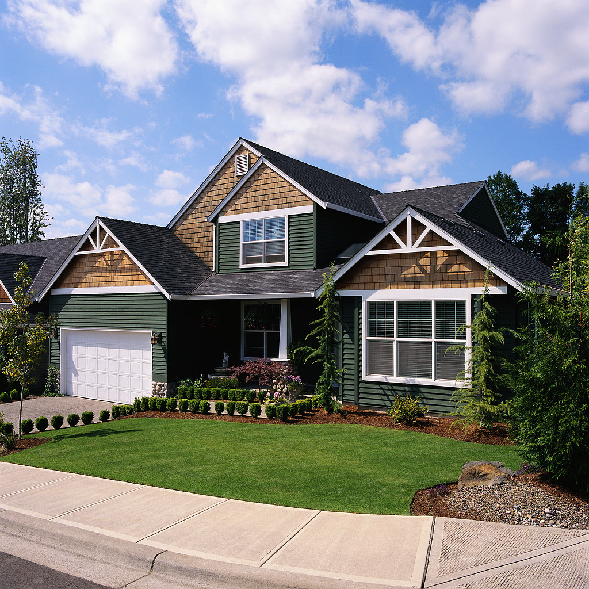
Proposed house when completed

Housing Developer:

You are a housing developer. You recently purchased a 100 acre tract of land on the Raging river. It had been a family farm years ago, but it has not been farmed in many years. The property is rolling hills that were once cropland. About 20 acres are in woodland. Fifteen acres of the woodland are near the Raging River and five acres are in an area about half way up one slope. You have not yet decided what to do with the woodland areas. You have subdivided the property and sold ½ acre lots. You are the sole contractor and you are in the process of building large homes on the lots. Many construction sites have been started at the same time and 13 houses are in various stages of construction. Five houses are totally complete, but the lawns are not yet planted or landscaped.

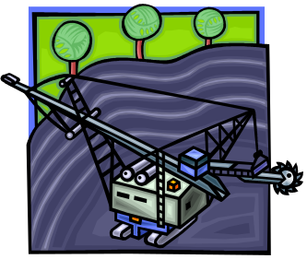

Mining Operation:

You own a company that is strip mining coal (removing coal from the surface of the earth). All top soil is removed and stored and saved. The mine covers 350 acres. The top soil will be replaced after the coal has been stripped. The potential to cause acid mine drainage is great. The strip mine is in gently rolling terrain and the Shining Stream is at the bottom of one of the valleys of the mine among other problems. Many people in the area rely on wells for their drinking water.



Shopping Mall:

You own 40 acres that you are hoping to develop into a shopping mall. The mall will potentially employ hundreds of people. It will have 50 stores ranging from small shops to two story department stores. It will have a six-acre parking lot with and an additional two-acre three story parking garage. It is in the Raging River watershed. This is a climate with cold, snowy winters.



Jaguar, BMW, and Mercedes Garage:

You own a successful automotive repair garage. You always have ten or twelve cars waiting in the parking lot to be repaired. You employ fifteen people. Twelve of these people are mechanics, two are receptionist/secretaries and one person is in charge of housekeeping and clean-up. You do all types of repair, from oil changes to full engine rebuilds and body work, including body repair and painting. The garage is in an industrial area with very little grass. The parking lot has a total of sixty spaces for the garage use. Of these spaces 30 spaces are reserved for cars that are in various stages of repairs or waiting to be picked up. You also have parking spaces for your workers and customers. It is in the Raging River watershed.

